**Social Media Engagement Metrics Analysis - Entertainment Sector**

Pooja Joshi & E.Code [E25007]

# Overview :

# In this report, we present the analysis of social media engagement metrics in the entertainment sector. This analysis focuses on the calculation of engagement rates and average ratings for various movies and shows, utilizing a dataset that includes metrics such as popularity and attendance count

# Objective:

The main objective is to calculate and analyze the engagement rates and average ratings of movies based on their popularity and audience attendance. This will help identify trends and insights into social media performance.

# Assigned Task(s) :

* Calculate Engagement Rate.
* Compute Average Ratings by Media Type.
* Analyze trends and correlations between various metrics.

# Task Details :

**Task 1:** Calculate Engagement Rate

* **Status:** Completed
* **Details:** Engagement rates were successfully calculated for each movie using the available data. This allows the measurement of audience interaction with the content.

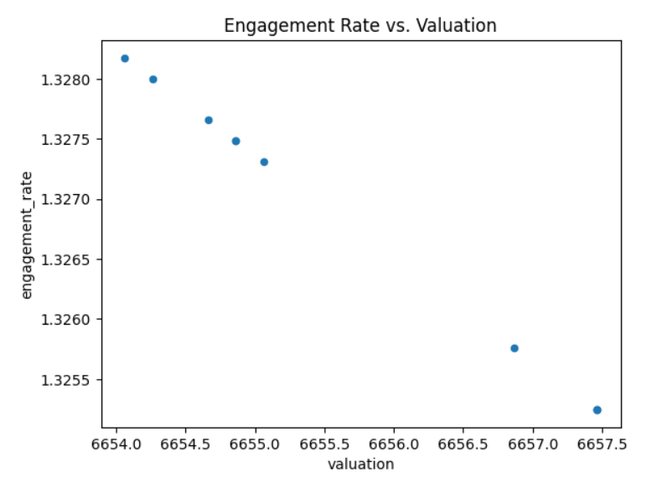

**Task 2:** Calculate Average Ratings

* **Status:** Completed
* **Details:** The average rating of movies in the dataset is approximately 7.74, which provides insights into audience preferences.

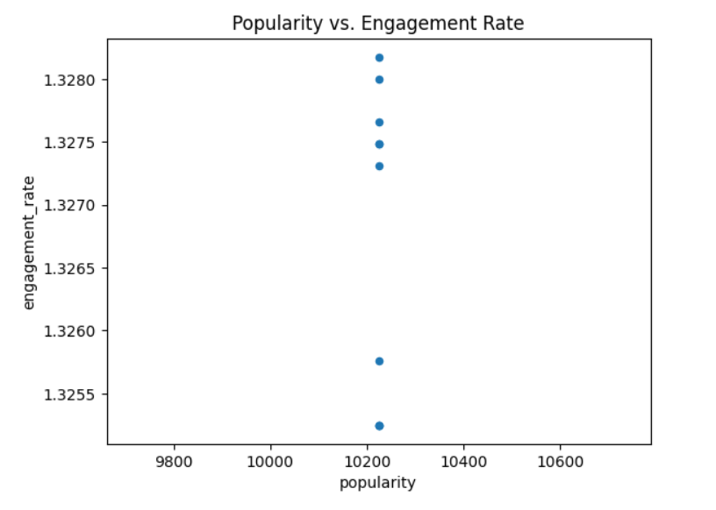

**Progress :**

**Accomplishments:**

    Successfully calculated engagement rates for all entries in the dataset.

Determined the average rating per media type, revealing insights into audience preference

**Metrics:**

Engagement rates and average ratings have been successfully computed.

· Sample Output:

Average Rating per Media Type:

| Media Type | Average Rating |
| --- | --- |
| Movie | 7.742 |

# Challenges and Solutions :

· **Challenge:** Missing values in the attendance_count column could have skewed engagement metrics.

· **Solution:** Missing values were handled through data cleaning techniques.

# Next Steps :

**Upcoming Tasks:**

     Conduct further analysis on trends in engagement rates over time (if temporal data is available).

    Explore additional metrics, such as sentiment analysis from social media comments or shares.

**Goals:**

    Set a target to complete the trend analysis by the next reporting period and prepare visualizations for a clearer understanding of the data.

# Conclusion :

# **Summary**: In conclusion, this report analyzed social media engagement metrics, calculating engagement rates and average ratings based on popularity and attendance. The results highlighted varying audience interactions and preferences for higher-rated content. By addressing data challenges, the analysis provided accurate insights, offering valuable guidance for optimizing future content strategies and audience targeting.

# **Acknowledgments**: Thank the audience for their time and attention.

# Instructions:

1. Use Google Docs. Single Column
2. TNR stands for Times New Roman: B - Bold
3. Use images as required with proper references
4. Use charts, tables as per your requirement.
5. Number of Pages: 2 to 8 for each task report.